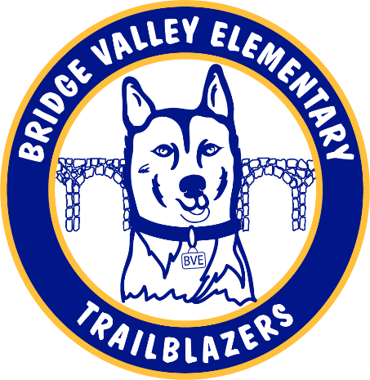

Agenda

**HSA General Membership Meeting Minutes**

**Thursday, November 17, 2022**

**7:00 p.m.**

**Bridge Valley Elementary School**

Board Members In-Attendance: Kevin Cochran, Kate Diebert, David Gitman, Jen Hoff, Mark Hoff, Heather Howard (Virtual), Victoria Russay

1. Mark (Hoff) called the meeting to order at 7:06 PM
2. Bridge Valley’s student council provided an update on their goals for the current school year.
3. Mr. Cochran provided the principal’s report
4. David (Gitman) provided the Treasurer’s Report
   1. Mr. Cochran discussed plans to use the budgeted 10K for student wish list items including a hydroponics garden tower.
      1. The tower produces approximately 30 lbs. of vegetables every 30 days.
      2. Mrs. Rittenhouse (Quest) has volunteered to coordinate grade level activity.
   2. Mr. Cochran advised that approximately $7500 of teacher grants have been requested thus far and he expects more to come in.
5. Heather (Howard) motioned for approval of the minutes from the September 28, 2022, General Membership Meeting
   1. Motion was seconded by Mark (Hoff) without objection.
   2. 9/28/22 General Membership Meeting minutes were approved.
6. Mark provided the President’s Report
7. Committee Reports
   1. Book Fair
   2. Teacher Appreciation – accepting cash/check donations
   3. Gardening
   4. Yearbook – Theme is Dream Big
8. New Business/Public Comment
   1. Students presented ideas for revamping and renaming the Father/Daughter and Mother/Son events.
9. Meeting was Adjourned by Mark at approximately 8 PM

Next Meeting: February 2, 2023, 7:00 p.m., Bridge Valley Elementary School